er

Punt Datasets and Attributes Manual
November 21, 2018

Contents
Introduction 3
Game Data 4
Play Information 5
Player Punt Data 6
Play Player Role Data 6
Video Review 6
NGS (Next Gen Stats) 9

Introduction

This manual describes the datasets and variables provided for the analysis of football punt plays. The data provided for analysis are specific to punt plays during the 2016 to 2017 seasons. Four different data sources are provided which describe various elements of each punt play and player. This manual describes the specifics of each variable contained with the datasets as well as guidelines on the best approach to use for analysis.

Databases

The following datasets will be provided for NFL seasons 2016 to 2017. Each dataset can be merged on the game, play or player level using the provided key variables (Table 1). GameKey provides a unique identifier for a specific game which is unique across NFL seasons. PlayID identifies a unique play within a specified GameKey. GSISID provides a unique identifier for a player across all seasons.

Table 1: Description of the datasets provided for analysis and their key variables.
 |  | Key Variables
Database | Description | GameKey | PlayID | GSISID
Game Data | game day and home team information | x
Play Information | play level data - score / play description | x | x
Player Punt Data | Player position specific to punt plays |  |  | x
Video Review | Detailed description of concussed player and partner attributes | x | x | x
NGS | Position and speed data for each player and play | x | x | x

Database Description

Game Data – game level data that specifies the type of season (pre, reg, post), week and the hosting city and team. Each game is uniquely identified across all seasons using GameKey.

Play Information – play level data that describes the type of play, possession team, score and a brief narrative of each play. Plays are uniquely identified using a its PlayID along with the corresponding GameKey. PlayIDs are not unique.

Player Punt Data – player level data that specifies the traditional football position for each player. Each player is identified using his GSISID.

Play Player Role Data -play and player level data that specifies a punt specific player role. This dataset will specify each player that played in each play. A player’s role in a play is uniquely defined by the Gamekey PlayID and GSISID.

Video Review – injury level data that provides a detailed description of the concussion-producing event. Video Review data are only available in cases in which the injury play can be identified. Each video review case can be identified using a combination of GameKey, PlayID, and GSISID. A brief narrative of the play events is provided.

NGS – Next Gen Stats – player level data that describes the movement of each player during a play. NGS data is processed by BIOCORE to produce relevant speed and direction data. The NGS data is identified using GameKey, PlayID, and GSISID. Player data for each play is provided as a function of time (Time) for the duration of the play.

Variable Definitions and Values

The following provides a description of each variable contained within the datasets and their corresponding values and meanings. Key Variables are designated in bold.

Game Data

Variable | Value | Meaning | Description
Season_Year | YYYY | NFL Season
Season_Type | Pre | Preseason
Season_Type | Reg | Regular Season
Season_Type | Post | Post Season
GameKey | ##### | numeric game identifier | unique across seasons
Game_Date | MM/DD/YYYY | date of game
Week | ## | week number | week is defined within Season_Type
Game_Day | text | day of the week
Game_Site | text | hosting city
Start_Time | 24:00:00 | time at start of game
Home_Team | text | long format of hosting team
HomeTeamCode | ABC | team abbreviation
Visit_Team | text | long format of visiting team
VisitTeamCode | ABC | team abbreviation
Stadium | text | Stadium Name
StadiumType | text | Indoor, outdoor or closure type - semi categorical
Turf | text | Natural or type of synthetic turf
GameWeather | text | description of indoor weather, same as "OutdoorWeather" for open stadiums
Temperature | degrees F | Stadium temperature
OutdoorWeather | free-form text | description of outdoor weather

Play Information

Variable | Value | Meaning | Description
Season_Year | YYYY | NFL Season
Season_Type | Pre | Preseason
Season_Type | Reg | Regular Season
Season_Type | Post | Post Season
GameKey | ##### | numeric game identifier | unique across seasons
Game_Date | MM/DD/YYYY | date of game
Week | ## | week number | week is defined within Season_Type
PlayID | #### | numeric play identifier | not unique across games - requires GameKey
Game_Clock | mm:ss | game clock at start of play
YardLine | ABC - ## | Play level line of srimmage
Quarter | 1 | First quarter
Quarter | 2 | Second quarter
Quarter | 3 | Third quarter
Quarter | 4 | Fourth quarter
Quarter | 5 | Overtime
Play_Type | Rush | Rushing / run play
Play_Type | Pass | Passing play
Play_Type | Kickoff | Kickoff play
Play_Type | Punt | Punt play
Play_Type | Extra Point | Extra Point
Play_Type | Field Goal | Field Goal
Poss_Team | Same as "Team" | identifies team with possession
Home_Team_Visit_Team | ABC-ABC | Abbreviation for Home - Visiting Team | Use with "Score_Home_Visiting"
Score_Home_Visiting | ##-## | Current score for Home - Visiting Team | Play level game score
PlayDescription | Free form | Description of play events | searchable for specific events

Player Punt Data

Player punt data assigns each player their typical football position.

Variable | Value | Meaning | Description
GSISID | ##### | unique player identification | unique across seasons
Position | ABC | typical player position - not punt specific
Number | ## | player jersey number

Play Player Role Data

Player Play Role data assigns each player a punt-specific role. These roles may differ by player between plays. This table also defines all players in each punt play. See the Appendix for a diagram of the Role definitions.

Variable | Value | Meaning | Description
Season_Year | YYYY | NFL Season
GameKey | ##### | numeric game identifier | unique across seasons
PlayID | #### | numeric play identifier | not unique across games - requires Gamekey
GSISID | ##### | unique player identification | unique across seasons
Role | ABC | Punt specific player information (see diagram in appendix)

Video Review

The Video Review dataset contains play and player information for each identifiable play that was associated with a concussion. For each injured player, the Primary Exposure is the impact that is observed to be markedly more severe than any other exposure during that play and was considered to be the primary source of the concussion. In some cases, the injury producing play can be identified, but the “Primary” event (helmet to helmet, helmet to body) cannot be identified. The “Primary Impact” will be listed as Unclear if the video coverage was adequate to observe all the events experienced by the player, but the competing exposures could not be differentiated to identify a primary. For plays in which the video coverage was not sufficient to visualize the player’s exposures, the primary exposure will be listed as Indeterminate. The data provided in the video review dataset will be only those for the primary impact.

Within the video review database, the prefix “Player” indicates the concussed player and “Partner” indicates the collision partner when applicable. If both the player and partner are concussed, then each player will be listed as a player.

Variable | Value | Meaning | Description
Season_Year | #### | NFL Season
GameKey | ##### | numeric game identifier | unique across seasons
PlayID | #### | numeric play identifier | not unique across games - requires GameKey
GSISID | ##### | unique player identification | unique across seasons
Player_Activity_Derived | Blocked | player was blocked | player activity during primary injury causing event
Player_Activity_Derived | Blocking | player was blocking | player activity during primary injury causing event
Player_Activity_Derived | Tackled | player was tackled | player activity during primary injury causing event
Player_Activity_Derived | Tackling | player was tackling | player activity during primary injury causing event
Player_Activity_Derived | Diving/Leaping | player was diving or leaping | player activity during primary injury causing event
Player_Activity_Derived | Other | other activity | player activity during primary injury causing event
Turnover_Related | Yes | concussion causing event related to a turnover | identifies concussions that were related to a turnover during the play
Turnover_Related | No | turnover had no relation to concussion
Turnover_Related | NA | not applicable
Primary_Impact_Type | Helmet-to-body | helmet to partner's body impact | categorical variable defining the impacting source that caused the concussion
Primary_Impact_Type | Helmet-to-ground | helmet to ground impact
Primary_Impact_Type | Helmet-to-helmet | helmet to helmet impact
Primary_Impact_Type | Indeterminate | primary exposure could not be visualized
Primary_Impact_Type | Unclear | primary exposure could not be differentiated from other contacts
Primary_Impact_Type | Unidentifiable | injury play could not be identified
Primary_Partner_GSISID | ##### | unique player identification | impacting player involved with primary helmet impact (not applicable for helmet to ground impacts)
Primary_Partner_Activity_Derived | Blocked | partner was blocked | categorical variable describing primary partner’s activity at the time of causing the concussion
Primary_Partner_Activity_Derived | Blocking | partner was blocking
Primary_Partner_Activity_Derived | Tackled | partner was tackled
Primary_Partner_Activity_Derived | Tackling | partner was tackling
Primary_Partner_Activity_Derived | Diving/Leaping | partner was diving or leaping
Primary_Partner_Activity_Derived | Other | other activity
Friendly_Fire | Yes | player and partner on same team | friendly fire occurs when the primary impact results from contact between two players on the same team
Friendly_Fire | No | player and partner on different teams
Friendly_Fire | Indeterminate | primary exposure could not be visualized
Friendly_Fire | Unclear | primary exposure could not be differentiated from other contacts
Friendly_Fire | NA | Not applicable | e.g. helmet to ground impact

NGS (Next Gen Stats)

The NGS datasets contains player position, speed and direction data for each player during the entire course of the play. The NGS dataset is the only dataset that contains Time as a variable.

When processing NGS data, it is recommended to calculate velocity direction using the x, y position data and use those calculated velocities for any analyses. If acceleration is desired, differentiating the NGS velocity data is recommended. The NGS data is in units of yards, so the final analyses should be converted to meters. The origin for the x and y coordinates is defined as the corner of the home endzone and home sideline (Figure 2). The angles defined by orientation and direction are referenced from the y-axis of the coordinate system.

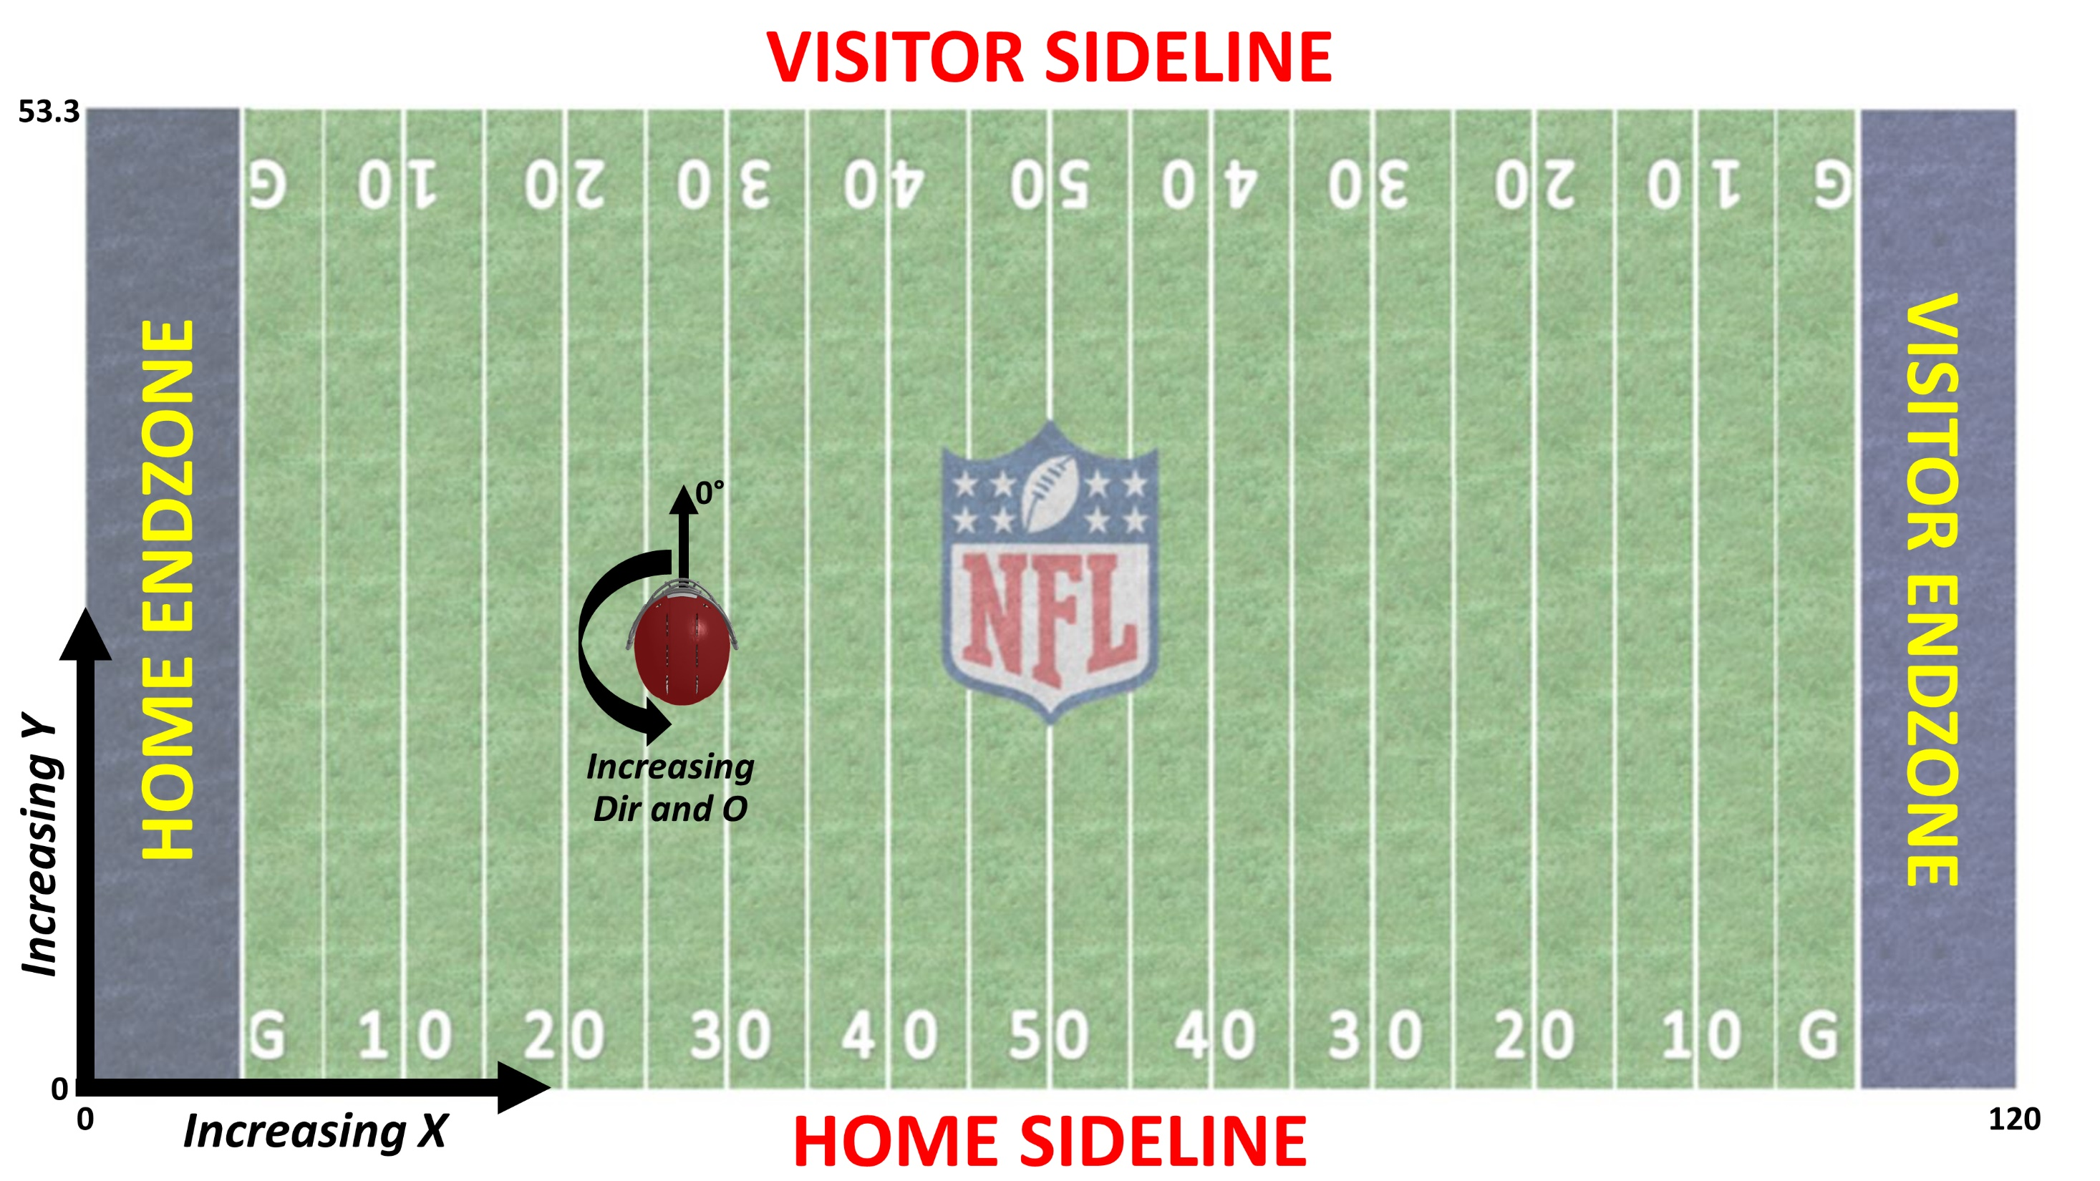
Figure 2: Coordinate system and origin (bottom left) used with the NGS position data.

Variable | Value | Meaning | Description
Season_Year | #### | NFL Season
GameKey | ##### | numeric game identifier | unique across seasons
PlayID | #### | numeric play identifier | not unique across games - requires GameKey
GSISID | ##### | unique player identification | unique across seasons
Time | MM/DD/YYYY HH:MM:SS | time of day at start, does not equal game clock | should be set to zero at start of play
x | numeric | player position along the long axis of the field (yards) | 0 - 120 yards
y | numeric | player position along the short axis of the field (yards) | 0 - 53.3 yards
s | numeric | Speed (yards/s)
dis | numeric | distance traveled from prior time point | Distance (yards)
o | numeric | Orientation - angle that the player is facing (deg) | 0 - 360 degrees
dir | numeric | Direction - angle of player motion (deg) | 0 - 360 degrees
Event | text | play details as a function of time during the play

Appendix – Punt Player Position (Role)

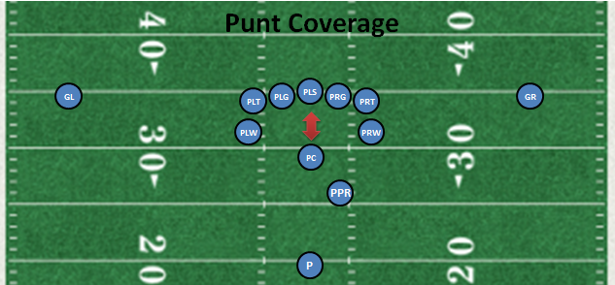

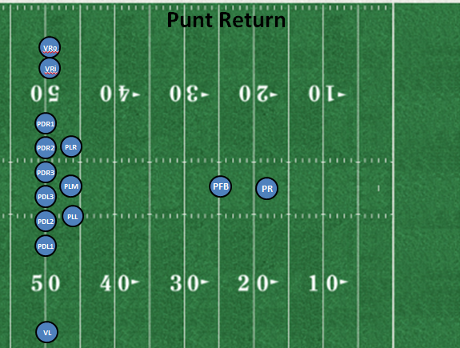
Appendix – Punt specific position – “Role”

